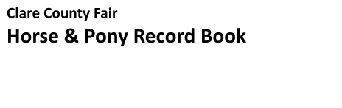
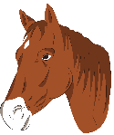
Guidelines:
Each youth is eligible to complete one (1) record book a year on one (1) of their horse or
pony projects.
●
- Provide information for the current year, September 1 to August 31.
- Assemble book in the following order (current year first):
  - Title Page (this page)
  - Project Information Page
  - Project Management
  - Project Photographs
  - Judge’s Comments
- Judged by 4-H age categories: 6-9, 10-12, 13-15, 16-19
- Must be submitted to the Clare County Fair Office for judging by 8:00pm on Sunday of Fair week.
- Winners will be announced at Fair.
- Note: Each year keep the pages from this record book in a binder as this is a progressive project record book and should illustrate the knowledge you have gained over the years in your project area. Record Books can be picked up from the MSU Extension Office after judging takes place.
- Please write clearly using blue or black ink
- Youth can add additional pages and or information to this record as they see fit.
Youth’s Name: _________________________________________________________________
Club Name: ____________________________________________________________________
Project Leader’s Name: __________________________________________________________
Year Project was Completed: ___________ Is this your first year in this project? ___ Yes ___ No
Youth’s Age (as of January 1): __________________
Youth’s Signature: ______________________________________________________________
I, the youth exhibitor , acknowledge that I have completed this record book to the best of my ability and find it to be complete.
Parent/Guardian’s Signature: ______________________________________________________
I, the parent/guardian, certify that my child has completed this project and completed this record book and will comply with all guidelines. I give permission for this record book to be displayed to the public and will ensure that all content is appropriate.
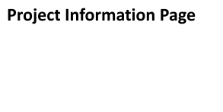
Name or Description of Project: ____________________________________________________
______________________________________________________________________________
Breed(s): ______________________________________________________________________
Gender: _______________________________________________________________________
Birth Date or Estimate: _________________ Date of beginning of Ownership: ______________ My project was: ___Born on my farm ___Purchased ___Other (Explain) ___________________
What factors did you consider when selecting your project (breed, age, price, disposition, etc.):
______________________________________________________________________________
______________________________________________________________________________
What disciplines do you currently ride or show? ______________________________________
______________________________________________________________________________
______________________________________________________________________________ Are there any new disciplines you want to try? Explain: _________________________________
______________________________________________________________________________
______________________________________________________________________________
Explain one goal that you had for this project this year: _________________________________
______________________________________________________________________________
______________________________________________________________________________
Explain one challenge you faced with your project this year: _____________________________
______________________________________________________________________________
______________________________________________________________________________
What did you learn by completing this project this year? _______________________________
______________________________________________________________________________
______________________________________________________________________________
How have you helped others to be successful in this project area this year: ________________
______________________________________________________________________________
______________________________________________________________________________
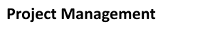
Vaccinations
Type given: ______________________________________________________________
Date given: ___________ Given by (circle one): Vet Yourself Parent/Guardian Other
Type given: ______________________________________________________________
Date given: ___________ Given by (circle one): Vet Yourself Parent/Guardian Other
Farrier Work
Trim or Shoe: _______________ If shoes on, why? ______________________________
Date(s): _________________________________________________________________
Dental work
Work done: ______________________________________________________________
Date(s): _________________________________________________________________
Deworming
Type given: ______________________________________________________________
Date(s) given: ____________________________________________________________
Grain
Type Fed: _______________________________________________________________
Amount Fed: ___________________________ How Often: _______________________
Supplements
Type: ___________________________________________________________________
How Often: ______________________________________________________________ Hay
Type: ___________________________________________________________________
How Often: ______________________________________________________________
What management strategies did you use this year to improve the health and well-being of your project? __________________________________________________________________
______________________________________________________________________________
______________________________________________________________________________ ●
Include photos of youth and animal from this program year.
- Include dates of photos.
- Youth may add additional documentation of project here such as feed slips, receipts, etc.
- Add additional pages as needed.

Judge’s Comments
This section is reserved for the judge’s comments to provide feedback.
The youth did the following areas well: ______________________________________________ ______________________________________________________________________________
______________________________________________________________________________
The youth could improve on the following areas: ______________________________________
______________________________________________________________________________
______________________________________________________________________________
Additional Comments: ___________________________________________________________
______________________________________________________________________________

